Ex. No. 2 | JAVA LOOPS
YouTube Link | http://localhost:3000/dashboard
Date of Exercise | 21/12/2006

Aim
To demonstrate and understand the fundamental loop constructs in programming: `for`, `while`, and `do-while` (or its equivalent simulation), illustrating their control flow mechanisms.

Description
Loops are control flow statements that allow a block of code to be executed repeatedly based on a given condition. They are essential for tasks requiring iteration, such as processing elements in a collection, performing calculations until a specific state is reached, or handling repetitive operations. The `for` loop is typically used when the number of iterations is known in advance or when iterating over a sequence. The `while` loop executes a block of code as long as a specified boolean condition is true, checking the condition before each iteration. The `do-while` loop (or its equivalent pattern in languages like Python) guarantees that the block of code is executed at least once before the condition is evaluated for subsequent iterations.

Program
# This Python program demonstrates general looping concepts, analogous to those found in Java.
# The request specified Python code for the 'program' field, despite the primary topic being 'java loops'.
print("--- Demonstrating Looping Concepts (Python) ---")
# 1. For Loop (similar to Java's enhanced for loop or iterating over collections)
print("\n1. For Loop (Iterating over a range - 1 to 5):")
for i in range(1, 6): # range(start, stop) - stop is exclusive
print(f" For loop iteration: {i}")
# 2. While Loop (Executes as long as a condition is true)
print("\n2. While Loop (Counting down from 3):")
count_while = 3
while count_while > 0:
print(f" While loop iteration: {count_while}")
count_while -= 1
# 3. Simulating a Do-While Loop (Executes at least once, then checks condition)
# Python does not have a direct 'do-while' construct, but it can be simulated.
print("\n3. Simulating Do-While Loop (Counting from 0 to 2):")
count_do_while = 0
while True:
print(f" Simulated Do-While loop iteration: {count_do_while}")
count_do_while += 1
if not (count_do_while < 3): # Condition check after the block
break
# Example with a condition that is initially false for while vs simulated do-while
print("\n4. Simulated Do-While vs While with initially false condition:")
x = 10
print(" While loop (condition x < 5 is false):")
while x < 5:
print(" This line will not be printed by while loop.")
break # Added break to prevent potential infinite loop if x were to change
print(" Simulated Do-While loop (condition y < 5 is false):")
y = 10
while True:
print(" This line will be printed at least once by simulated do-while loop.")
if not (y < 5): # Condition check after the block
break
print("\n--- Loop concept demonstration complete ---")

Output Screenshot
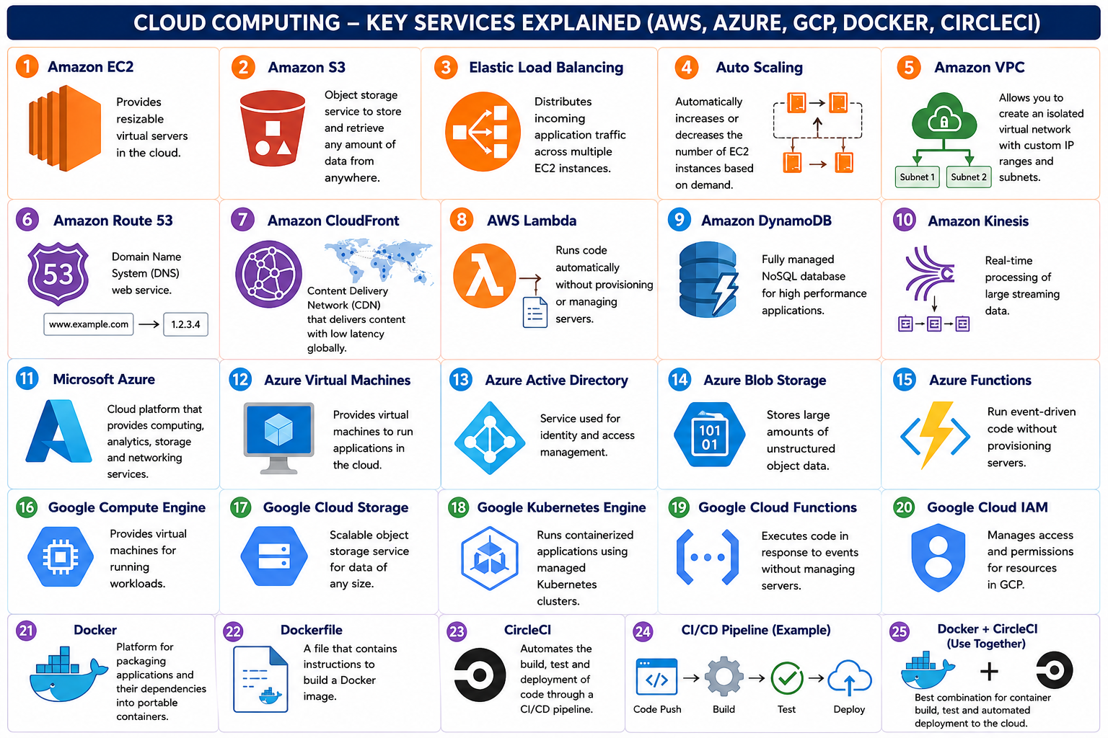

Result
The experiment successfully demonstrated the implementation and behavior of common looping constructs (`for`, `while`, and a simulated `do-while`) using Python. Each loop type executed its respective code block as expected, showcasing their distinct control flow mechanisms. The objective of understanding these fundamental loop concepts was achieved, providing a clear illustration of iterative execution patterns.

